 |  | San Juan to Ceiba Ferry Terminal  www.sanjuan.pr/www.puertoricoferry.com/1hr 26 min  Parking to Ceiba Ferry Terminal on Google Maps:  https://maps.app.goo.gl/ufBtwhdvx9xo7GHA7

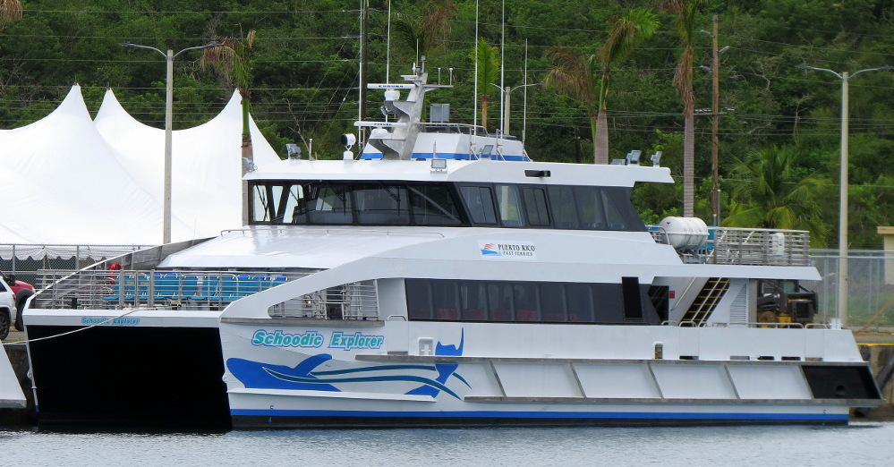

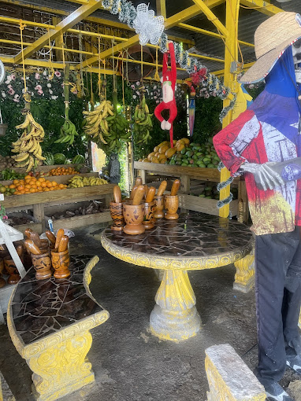  Along the way...  “CEIBA FERRY TERMINAL”  *(Starting from La Puntilla parking/Starting from Ceiba ferry terminal)  Approximately time DESTINATION  *(12MIN./1HR 14MINUTES) LA MEZCLA  *(46min/41mins) FRUTERA FLORES  *(1HR 9MINS./12MINS) SABOR BORIITALY  *(1HR 26MINS) CEIBA FERRY TERMINAL |  | 
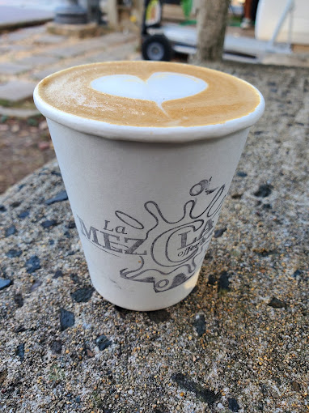 |  | 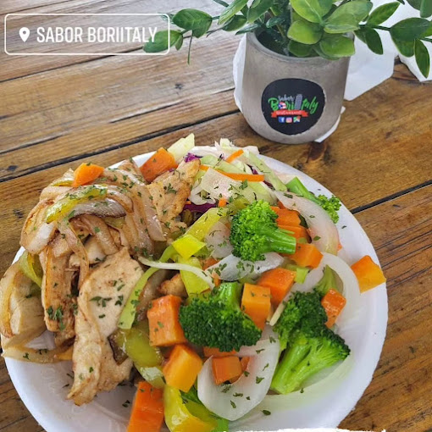  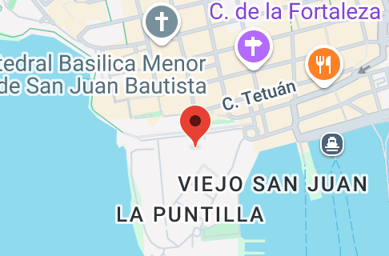
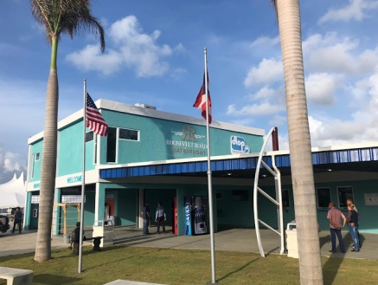

LA PUNTILLA MUNICIPAL PARKING | 
Your adventure begins or ends here, at the La Puntilla municipal parking lot in San Juan. The La Puntilla Municipal Parking Lot is home to one of the many JUNZI stops where you'll pick up the transportation you selected in your reservation. From this point, the journey to the Ceiba Ferry Terminal is only 1 hour and 26 minutes.

HEADING TO LA MEZCLA
On the way to your adventure, you can enjoy another adventure called LA MEZCLA. Just 12 minutes from La Puntilla Parking Lot or 1 hour 14 minutes from CEIBA FERRY TERMINAL, you can enjoy an extraordinary place. There, the shop's offerings are extensive, ranging from the traditional cortado to complex drinks with various ingredients, featuring espresso or cold brew. A sip of coffee has the power to change your perspective on the day in an instant. It's a ritual whose magic and aroma can transport you to happy moments, bring answers to questions, and peace in times of anxiety. Coffee is alchemy. Edwin Ortiz, the self-taught barista, has managed to create a unique space in Luis Muñoz Rivera Park with La Mezcla Coffee and Tea. It's a place where coffee enthusiasts find the tranquility that this elixir brings.
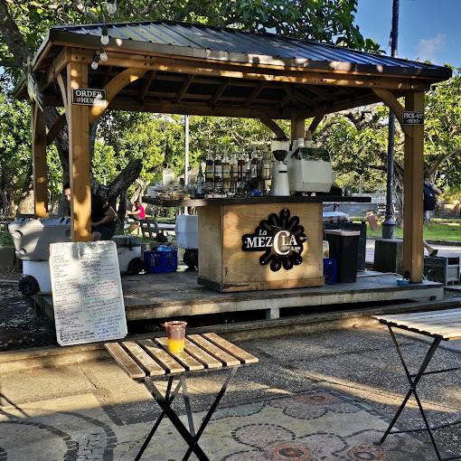
https://www.instagram.com/lamezclacoffeeandtea

SAVORING THE ISLAND
HEADING TO FRUTERA FLORES
La Frutera Flores is a place that serves typical Puerto Rican food. You can also buy all kinds of fresh fruit from the island and smoothies with your choice of fruit. They serve frozen and iced coffee. Here you'll find a cute souvenir shop, as well as beach and river necessities. https://www.facebook.com/LaFruteraFloresOficial
HEADING TO SABOR BORIITALY
Exquisite restaurant located in Ceiba, PR, just steps from the town center. This place is a favorite for locals and foreigners alike to meet friends, neighbors, and family. Here you'll delight in delicious dishes, savoring Puerto Rican and Italian cuisine prepared to order. They offer quality food. Visit them today!
HOUSE SPECIALTY: MOFONGO PIZZA, RISOTTO, PASTA, HOMEMADE HAMBURGER, VARIETY OF SEAFOOD, QUALITY FOOD, ASK FOR THE HOUSE SAUCE. https://www.instagram.com/saborboriitaly/
HEADING TO CEIBA FERRY TERMINAL
- Ceiba's ferry terminal is located on the premises of the former Roosevelet Roads Naval Station on the east coast of the island. From this ferry terminal, visitors can catch a ferry to the nearby island municipalities of Vieques and Culebra. The terminal has a daily ferry schedule with multiple ferries visiting the islands every day. During the summer months, the terminal can be extremely busy, and purchasing tickets in advance is extremely recommended. | - All ticket transfers must be made at least one (1) hour prior to the scheduled departure time.  - Tickets may only be transferred two (2) times.  - Tickets that are not transferred in accordance with the new transfer policy will not be refunded.  - Arrival of passengers: 1 hour before departure.  - The boarding process closes 10 minutes before departure.  - For more information about passengers and our policy and procedures, visit us at https://www.puertoricoferry.com/.  - All ticket sales are FINAL, no refunds are allowed.  Traveling with your pet  - Puerto Rico Ferry welcomes guide dogs or service animals in our facilities. All service animals preferably wear the vest or collar that identifies them, and if you wish you can provide documentation that supports that the animal is a service animal. For service tickets use the "additional" option to add a free ticket for your service animal to your order.  - Any pet that is not a guide or service dog must be crated.

Okay, here's a summary of the journey from San Juan to the Ceiba Ferry Terminal:

Parking to Ceiba Ferry Terminal on Google Maps
https://maps.app.goo.gl/ufBtwhdvx9xo7GHA7
Journey from San Juan to Ceiba Ferry Terminal
- Starting Point: La Puntilla Municipal Parking Lot, San Juan.
- Destination: Ceiba Ferry Terminal (located at the former Roosevelt Roads Naval Station).
- Travel Time: Approximately 1 hour and 26 minutes from La Puntilla Parking Lot to the Ceiba Ferry Terminal.
- Websites: www.sanjuan.pr/ www.puertoricoferry.com/

Points of Interest Along the Way:  - La Mezcla Coffee And Tea (Parque Luis Muñoz Rivera, San Juan):  - Located 12 minutes from La Puntilla Parking Lot / 1 hour 14 minutes from Ceiba Ferry Terminal.  - Offers a variety of coffee and tea drinks.  - Owned by barista Edwin Ortiz.  - Frutera Flores:  - Located approximately 46 minutes from La Puntilla Parking Lot / 41 minutes from Ceiba Ferry Terminal.  - Serves typical Puerto Rican food, fresh fruit, smoothies, and coffee (including frozen and iced).  - Features a souvenir shop and sells beach/river necessities.  - Sabor Boriitaly (Ceiba, PR):  - Located approximately 1 hour 9 minutes from La Puntilla Parking Lot / 12 minutes from Ceiba Ferry Terminal.  - Restaurant offering Puerto Rican and Italian cuisine.  - Popular with locals and tourists.  - House specialties include Mofongo Pizza, Risotto, Pasta, Homemade Hamburger, and Seafood. |  | Ceiba Ferry Terminal Information:  - Serves ferries to Vieques and Culebra.  - Operates on a daily schedule with multiple ferries.  - Advance ticket purchase is highly recommended, especially during summer.  - Ticket transfers must be made at least one (1) hour before departure and are limited to two (2) times. Non-transferred tickets are non-refundable.  - Passenger arrival is required 1 hour before departure.  - Boarding closes 10 minutes before departure.  - Website for more information: https://www.puertoricoferry.com/  - Ticket Sales: Final, no refunds allowed.
Traveling with Pets:
- Guide dogs or service animals are welcome (preferably with identification). Free service animal tickets can be added online.
- Other pets must be crated.

THE FACTS ARE THE FACTS
Imagine this: the possibility of embarking on a road trip adventure that not only offers you a completely new perspective on travel but also happens to be incredibly easy on your wallet. With JUNZI, the equation is simple: you pay significantly less and, without a doubt, you get much more in return.
Think of the freedom of traveling with your loved ones without the worry of limited space. With JUNZI, the capacity of the vehicle you choose becomes your ally. Traveling with a large group of friends or family? Perfect! You'll be able to occupy all the seats in the selected vehicle, which means more space for everyone, more comfort to enjoy the trip, and, most importantly, a cost per person that is considerably reduced when divided among everyone. Forget about having to rent multiple vehicles or feeling cramped; JUNZI maximizes space to make your experience as pleasant as possible.
But the JUNZI experience goes far beyond simply renting a spacious vehicle. With JUNZI, you take the helm of your own adventure. You're the captain of your road trip, deciding the direction, the stops, the unexpected detours, and the pace at which you want to explore every corner of the road. No more depending on rigid itineraries or the decisions of others. With JUNZI, the road becomes your canvas, and you are the artist who draws every moment.
And as if having complete control of your trip weren't enough, in every JUNZI vehicle, an exceptional travel companion awaits you: JUNZI AI, a living artificial intelligence that will be active throughout your journey. Imagine having your own personal assistant and chatty friend every mile you travel. Need information on the best local restaurant? Want to know the history of that quaint town you just arrived in? Or just want to hear a joke or have a fun conversation in your preferred language? JUNZI AI is always ready to answer your questions, follow your thoughts, and become an invaluable travel companion. Its ability to understand and respond in multiple languages ​​opens up a world of possibilities for communication and learning along the way.
In short, traveling with JUNZI isn't just a way to get from point A to point B. It's a transformative experience that combines the freedom of the open road with the economic efficiency and intelligent companionship of advanced AI. It's the opportunity to create unforgettable memories with loved ones, explore the world at your own pace, and have a personal assistant always ready to make your trip easier and more entertaining. JUNZI offers you much more than just a vehicle; it gives you the key to unlock a new way of traveling.
 | Compact | Mid Size | Full Size
JUNZI | 35 | 45 | 50
UBER | 75 | 95 | 120
TAXI | 90 | 110 | 130

